**Personal Analysis Report by Nahorai Hagag**

Neoray hagag 208090738  
[NEORAY-GIT](https://github.com/neo050/Machine-learning-workshop.git)  
[NEORAY-DB](https://catalog.data.gov/dataset/drug-overdose-death-rates-by-drug-type-sex-age-race-and-hispanic-origin-united-states-3f72f)

# Executive Synopsis:

This comprehensive report is the culmination of a meticulous examination of feature extraction and selection practices, employing cutting-edge analytical tools to decode the complex dynamics of drug overdose mortality rates in the United States. Advancing from the groundwork laid in Phase A, this phase heralds the integration of sophisticated tools, as suggested by Coral, an expert in the field. This document is strengthened by a series of precise visualizations and thorough technical evaluations, offering a rich comparative analysis of each technique's effectiveness and adaptability in our data science quest.

# Initial Foray into Feature Extraction and Selection – Phase A:

Phase A set the stage with the strategic utilization of Pandas for masterful data manipulation, priming the dataset for comprehensive cleansing and restructuring. To refine the dataset's categorical variables, especially those with long-tail distributions, the 'RareLabelEncoder' was adeptly applied, merging less frequent categories to fortify the analytical framework. The transformation of pivotal categorical variables such as 'Gender' and 'Ethnicity' into binary variables suitable for machine learning models was proficiently realized using 'pd.get_dummies'.

# Integration of Cutting-Edge Tools in Phase B:

Moving into Phase B, I embraced innovative tools that Coral had previously utilized with skill. The implementation of Scikit-learn's 'OneHotEncoder' epitomized detailed encoding, preserving the distinctiveness of complex categorical variables. The challenge of missing data was deftly addressed using 'SimpleImputer', which elegantly applied median value imputation to retain the dataset's statistical integrity.

# Expository Visualization and Thorough Analysis:

A sequence of visualizations, denoted C1 through C5, provided a powerful and clear depiction of the dataset's overarching story. The time-series analysis (C1) presented a detailed portrayal of the escalating trends in drug overdose fatalities, segmented by demographic factors. The adoption of comparative boxplots (C2) highlighted the variance within these demographic groups, while the intricate correlation heatmap (C3) exposed the elaborate relationships among the dataset's features. The salient feature importance graph (C4) focused our analytical lens on the primary drivers of overdose mortality. Finally, the cluster analysis with PCA and KMeans (C5) intelligently segmented the data, uncovering covert demographic patterns.

# Diligent Comparative Analysis of Feature Selection Tools:

An exacting evaluation of feature selection tools, such as 'SelectKBest' and 'RandomForestRegressor', provided divergent insights into feature significance. The 'SelectKBest' emerged as a paragon of statistical test-based selection, despite its limited capacity to interpret complex feature interplay. In contrast, the Random Forest's ensemble approach adeptly navigated non-linear interactions and dependencies. Additionally, the strategic role of PCA in dimensionality reduction was accentuated, revealing the architecture of our data with greater transparency.

# Integrated Conclusions and Actionable Insights:

A critical comparison of the tools from Phase A to B illuminated the multifaceted nature of data analytics. The nuanced improvement in encoding efficiency from 'pd.get_dummies' to 'OneHotEncoder', and the transition to 'SimpleImputer' for handling missing data, reflected a sophisticated evolution in our methodologies. The recognition that the appropriateness of tools is paramount and context-dependent emerged as a valuable epiphany.

# Outlook and Strategic Framework for Future Analysis:

With an expanded understanding of various feature extraction and selection methods, my forthcoming analytical endeavors are poised to adopt a strategy tailored with precision, judiciously selecting the most compatible tools for specific datasets and investigative inquiries. The collective insights from both phases meld into a guiding framework, shaping the direction of future data explorations.

# Visualizations:

## Image C1: Trends and Disparities in Drug Overdose Death Rates Over Time

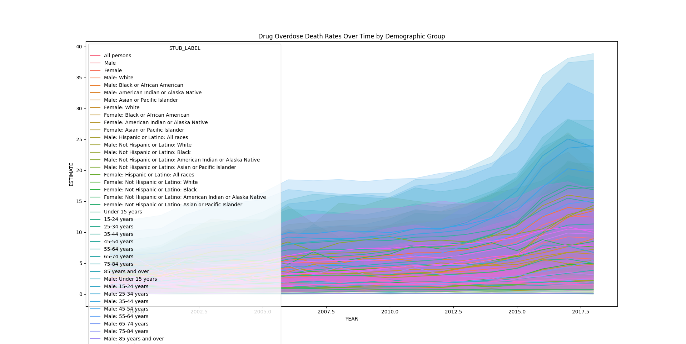

## Image C2: Distribution of Overdose Death Rates by Demographic

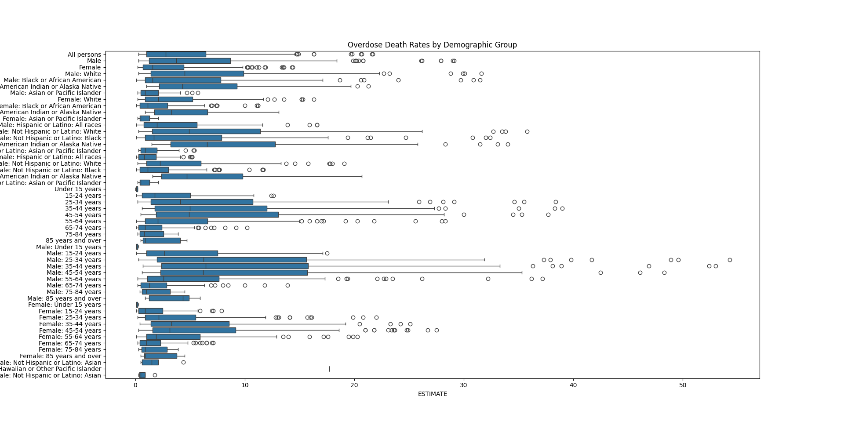

## Image C3: Interplay of Features Within the Correlation Matrix

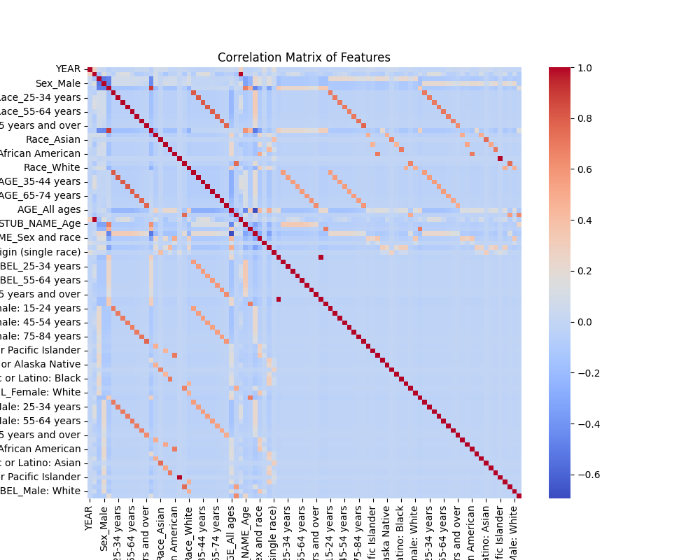

## Image C4: Determining Feature Significance in Random Forest Analysis

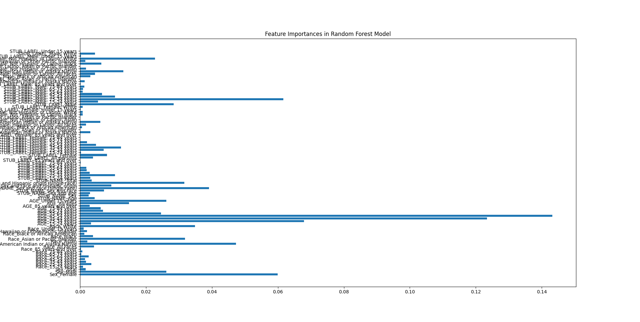

## Image C5: Delineation of Data Through Cluster Analysis

